1. Open the Windows PowerShell console.
2. Use the New-PSDrive cmdlet to create a drive mapping to the alias provider. The name of the new PS drive will be al. The -PSProvider parameter is alias, and the root will be dot (.).
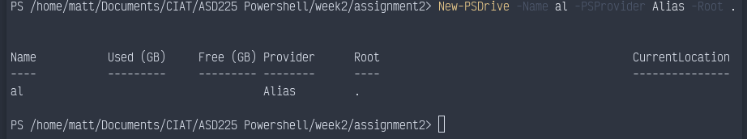
Insert picture of command and results

3. Change your working location to the new PS drive you called al. To do this, use the sl alias for the Set-Location cmdlet.
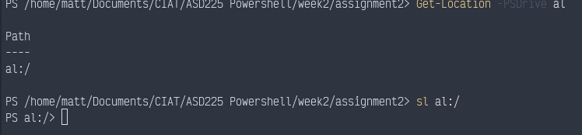
Insert picture of command and results

4. Use the gci alias for the Get-ChildItem cmdlet, and pipeline the resulting object into the Sort-Object cmdlet by using the sort alias. Supply name as the property to sort on.
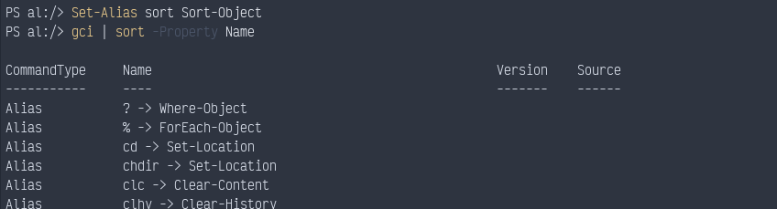
Insert picture of command and results

5. Press the Up Arrow key to retrieve the previous gci | sort -Property name command, and modify it to use a Where-Object cmdlet to return aliases only when the name begins with a letter after t in the alphabet. Use the where alias to avoid typing the entire name of the cmdlet.
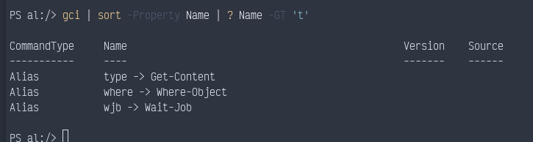
This one’s a little funny. Not sure why it’s including T in this. I would expect T to be excluded, and included in -GE, but it those both give the same results. -LT and -LE both give identical results too (A-S).
Insert picture of command and results

6. Change your location back to drive C. To do this, use the sl alias and supply the C:\ argument.
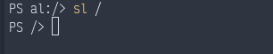
Insert picture of command and results

7. Remove the PS drive mapping for al. To do this, use the Remove-PSDrive cmdlet and supply the name of the PS drive to remove. Note that this command does not take a trailing colon (:) or colon with backslash (:\).
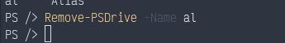
Insert picture of command and results

8. Use the Get-PSDrive cmdlet to confirm that the al drive has been removed.
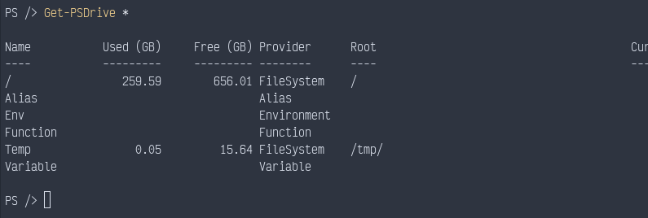
Insert picture of command and results

9. Use the Get-Item cmdlet to obtain a listing of all the environment variables. Use the -Path parameter and supply env:\ as the value.
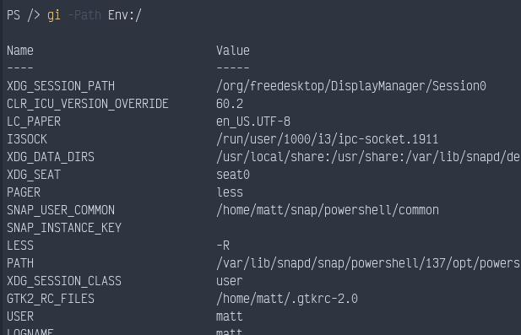
Insert picture of command and results

10. Press the Up Arrow key to retrieve the previous command, and pipeline the resulting object into the Get-Member cmdlet.
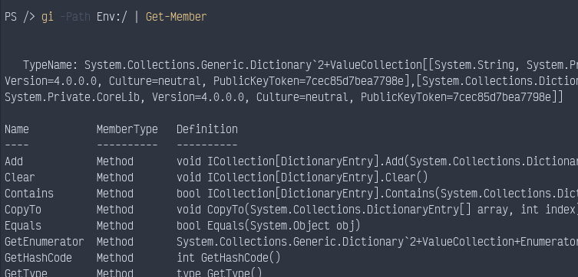
Insert picture of command and results

